# User Guide

## Programs Required:

* Visual Studio
* SQL Server
* A web browser

## System Requirements:

* 1.6 GHz or faster processor
* 1 GB of RAM (1.5 GB if running on a virtual machine)
* 27 GB of available hard disk space
* 5400 RPM hard disk drive
* DirectX 9-capable video card that runs at 1024 x 768 or higher display resolution

## How to Install:

1. Install Visual Studio and SQL Server.
2. Open SQL Server and load the server files on to view the database.
3. Open the web project in Visual Studio and change the connection string to the database to the local database setup on SQL server.

If this website was actually released the user would only need to go to the webpage to view the necessary information.

## Creating an Account

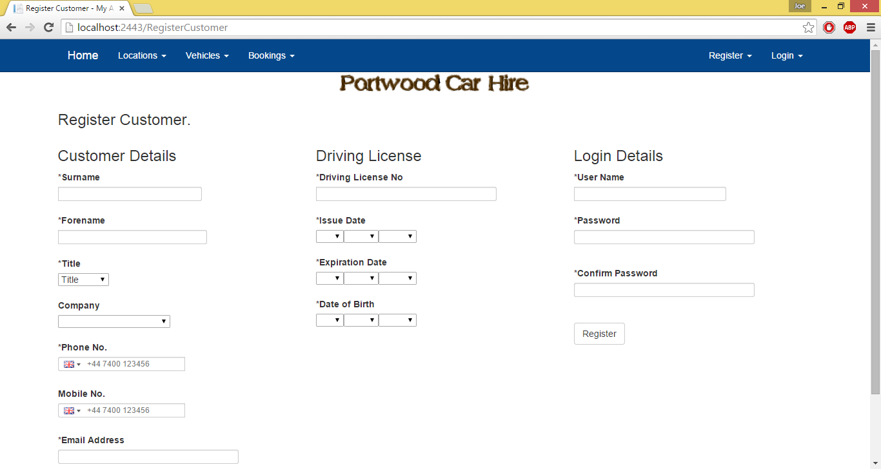

To create an account go to Register and then either click the company or customer button depending on what type of account you wish to create. Customers can only view vehicles, locations and book new hires whereas company accounts can create and edit all of these assuming they own them. To register a new account fill out the fields then you will be logged in after registering. If you login after registering your account be sure to remember your username and account and login on the correct page – either customer or company depending on your account type.

## Adding/Editing Locations

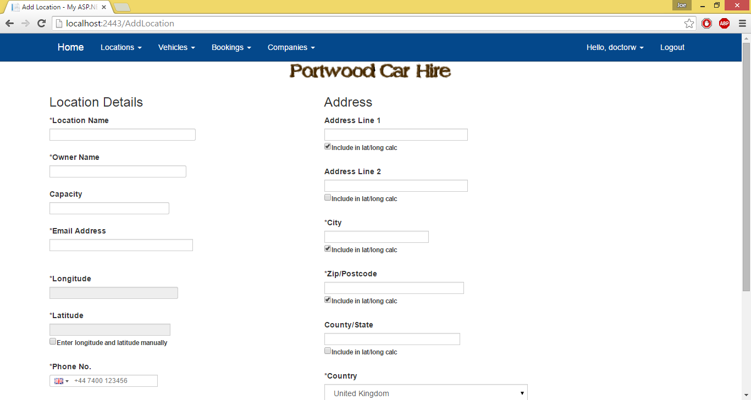

To add a new location make sure to be logged in as a company and then go to Locations->Add location. You can either enter the longitude and latitude of the location manually or fill out the address and press on the get longitude and latitude button. Once the get longitude and latitude button has been pressed you will not be able to edit the address unless the edit address button is pressed. The location will then be viewable on the home and view locations pages.

To edit a location follow the same steps as above but go to locations->edit location and edit a location that has already been entered. When editing a location setting active to no will mean that the location is no longer displayed on the map.

### Opening Times

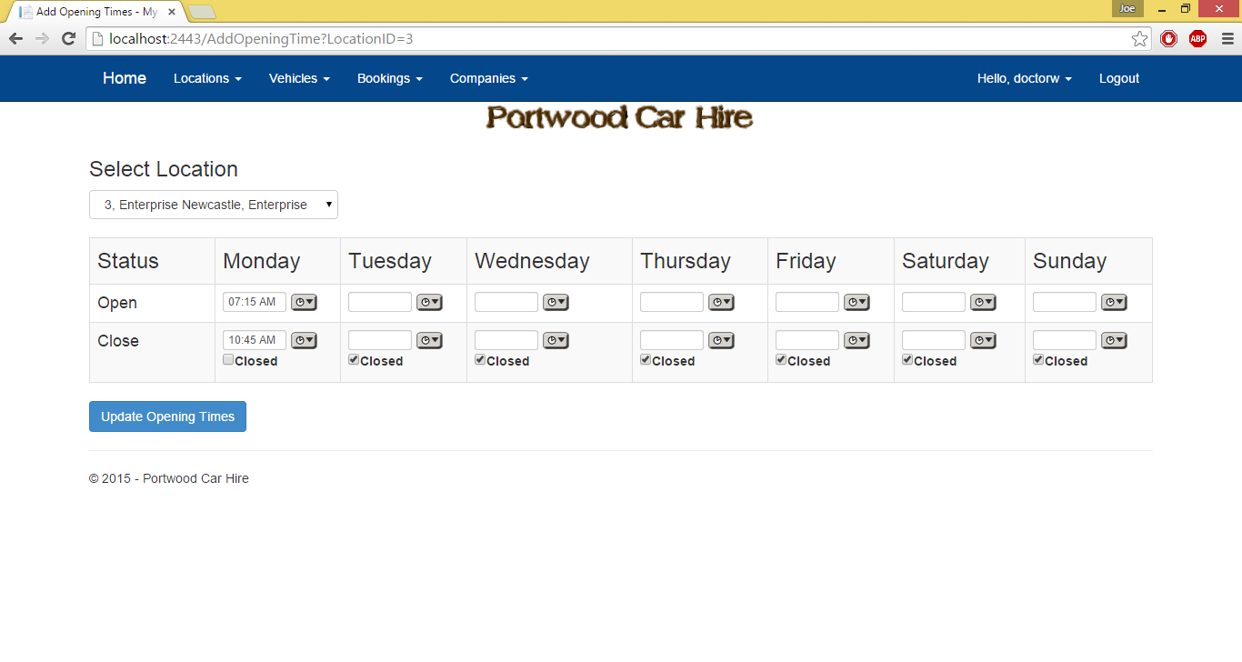

To manage the opening times of a location you must be logged in as a company and have a location on the system. Go to Locations->Add Opening Time and select a location you own from the dropdown and then the opening times will be displayed for this location. To change the opening times either enter the times in am/pm format or click on the clock button to select from a list of times. Make sure the closing time is after the opening time. Once the desired times are selected click the update opening times.

### Holiday Opening Times

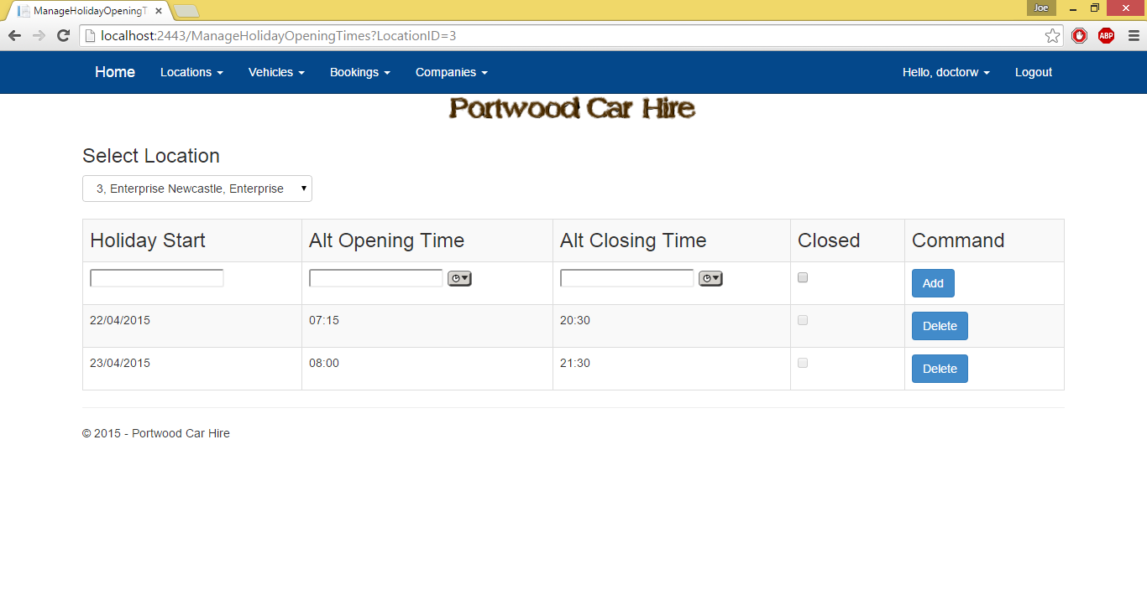

Go to Locations->Manager Holiday Opening Times and select a location you own. To add a new time make sure a time for the same date is not entered then select the times you wish to set for the holiday.

## Adding/Editing Vehicles

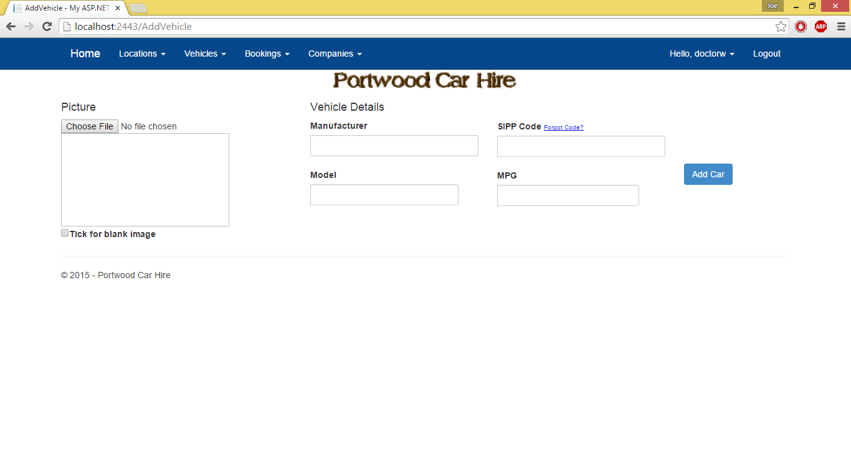

To add a new vehicle you must be logged into a company account. Go to Vehicles->Add Vehicle then enter the information of the vehicle you wish to enter. When choosing an image of the vehicle make sure that the file is in JPEG format. The SIPP code is 4 digits long and you can click the Forgot Code hyperlink for more information.

For editing a vehicle go to Vehicles->Edit Vehicle and select the vehicles from the ones you own. Due to there being duplicates you must then select the relevant vehicle from the table that is shown and once this is selected follow the same steps as adding a vehicle.

## Adding/Editing Bookings

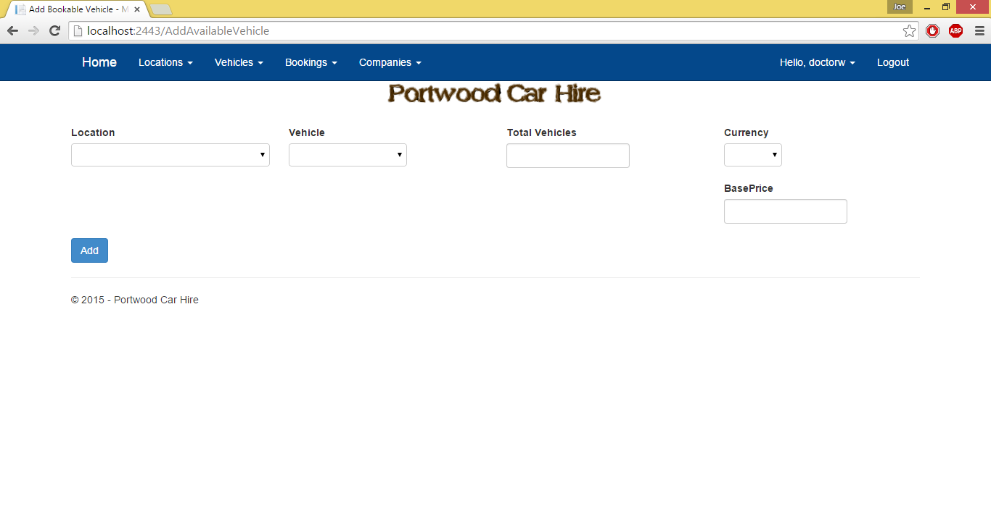

To add a new bookable vehicle to the system you must be logged in on a company account. Go to Bookings->Add Booking Select a location that you own and a vehicle that you own then fill out the remaining fields and add the vehicle to be bookable. If this vehicle is already listed at this location you cannot add it again.

To edit a bookable vehicle go to Bookings->Edit Booking and the page will look similar apart from only bookable vehicles that are already listed will be available to view.

## Using the Map

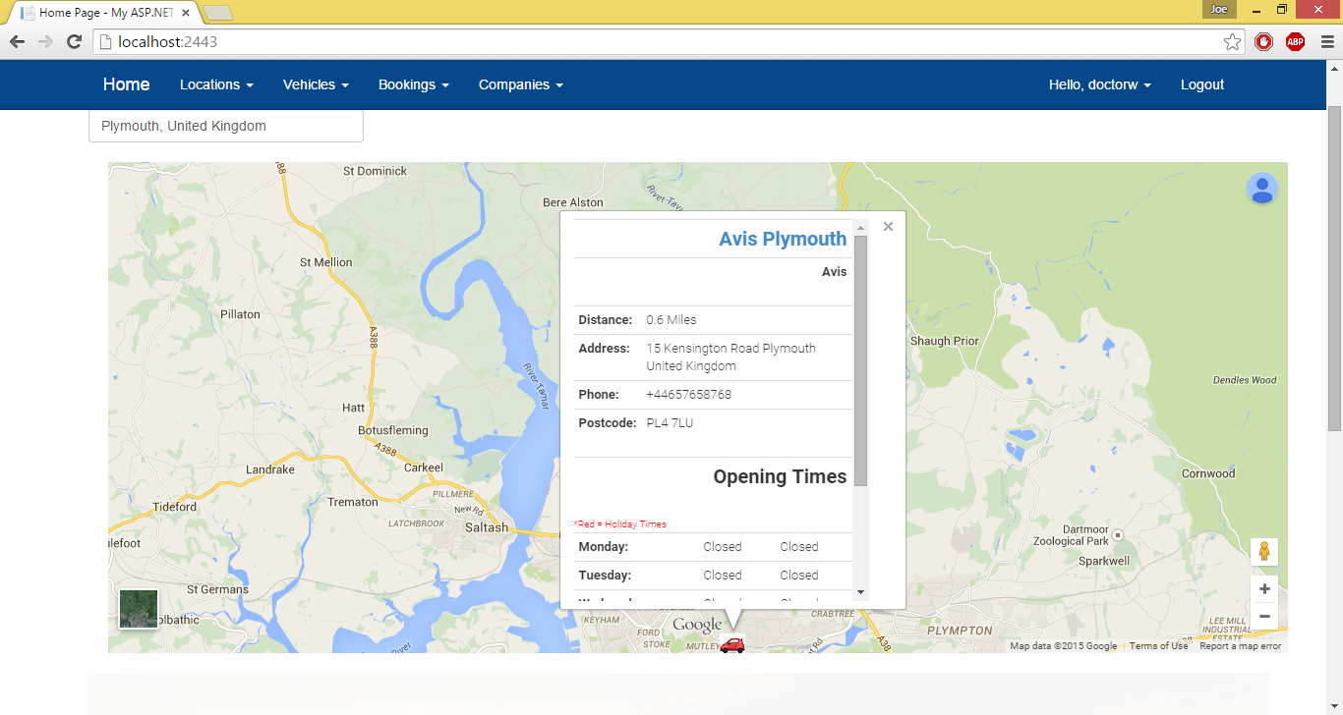

To use the map you can either find the location you’re look for by clicking, dragging and zooming in to where you want to book from or type your address in the address box and see car hires that are located near to you. Once you find a location you want to book from you can click on the car icon on the map which should bring up a box with information about the car hire location. The hyperlinked title at the top of this box will take you to the page listing all vehicles that are available at the location that was clicked on.

## Making a Booking

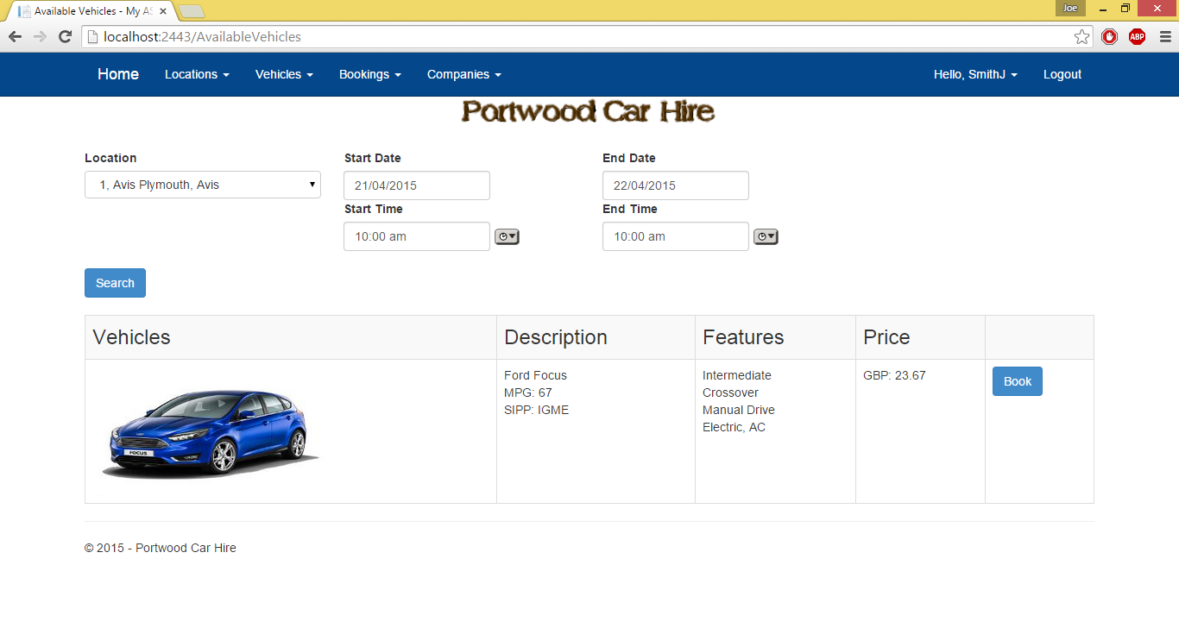

If you got to this page by clicking on a hyperlink on the map then all vehicles for that location will be displayed. Otherwise the location of where the booking is needs from the location list then the search button pressed to view all the vehicles available at that location. Select the times you want to book between then click the book button for the vehicle you want to hire.

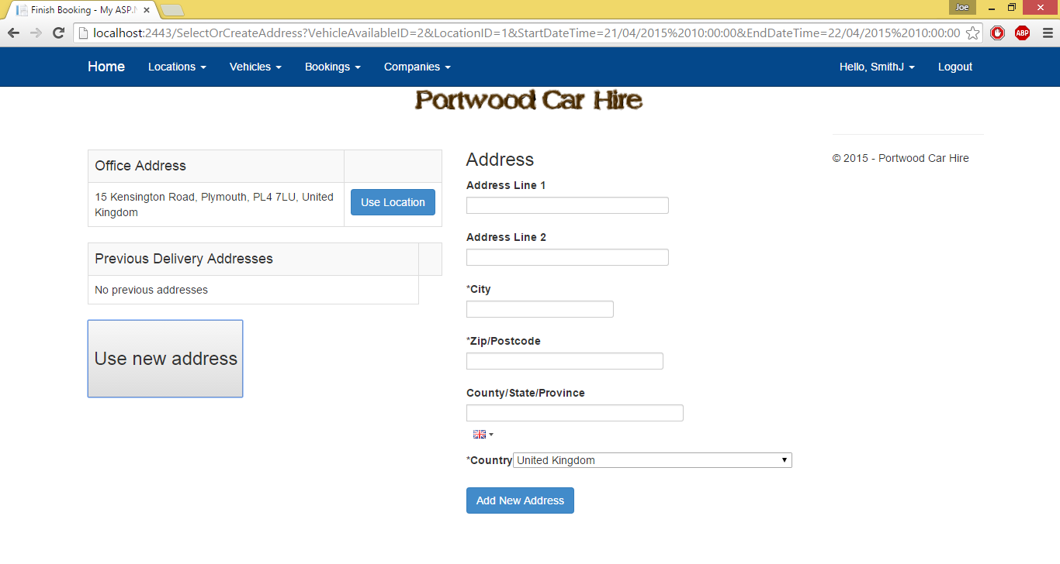

If you are a company booking on a customer’s behalf then select the customer you want to book for from the dropdown menu. The customer must be part of your company to do this.

No matter what account type you are logged in as select the address you wish to hire from. This can be the location address, a previous address that you used or a new address. Please be aware that if the address is too far away from the company then your booking may be declined.

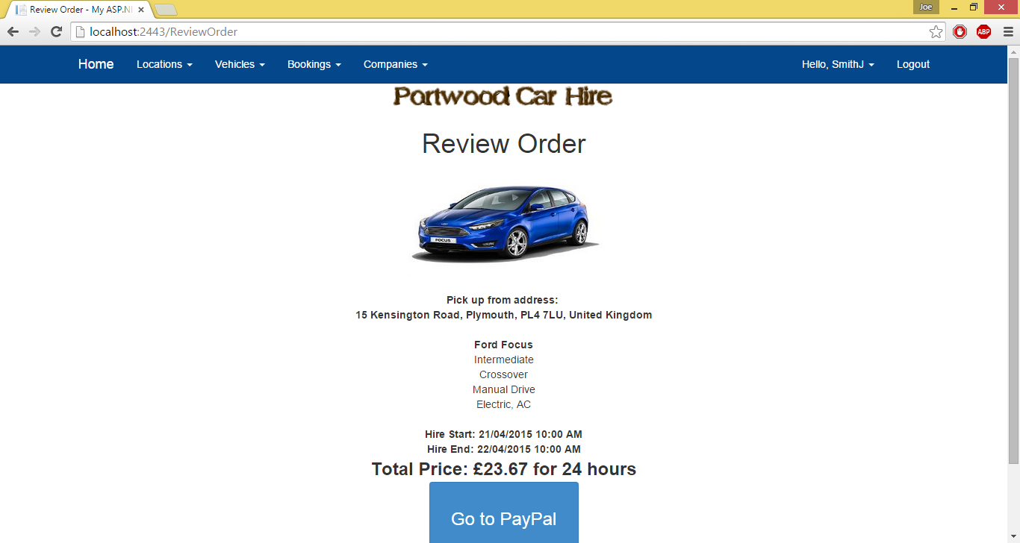

Review your order so far and if you’re happy with it proceed to PayPal.

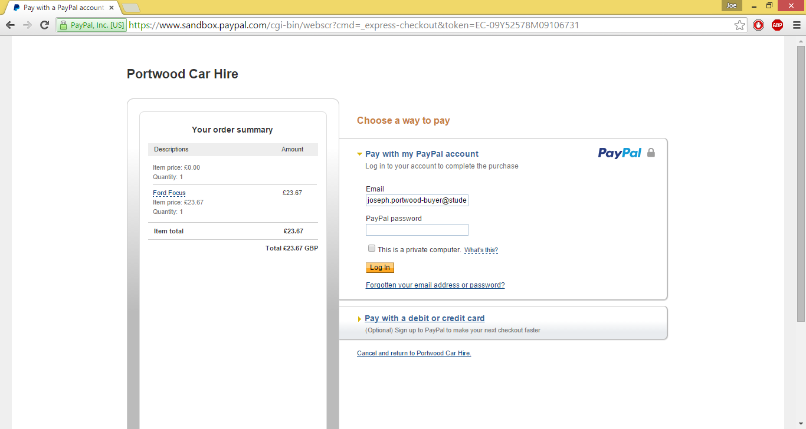

Fill out your PayPal information.

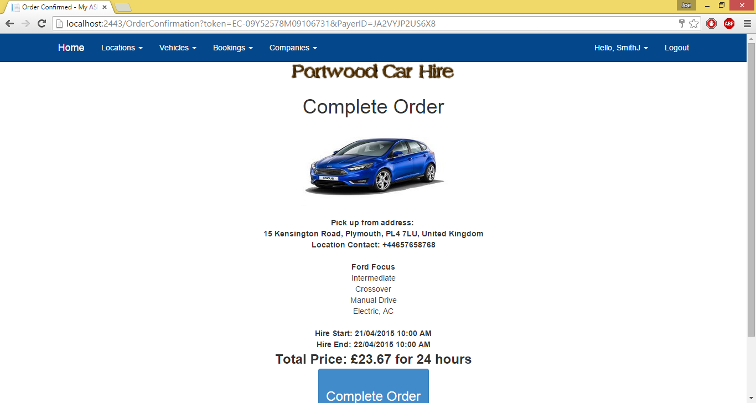

Once the complete order button is pressed your booking has gone into the system and the new page will show the PayPal account you paid on should you want to keep this information for your records.